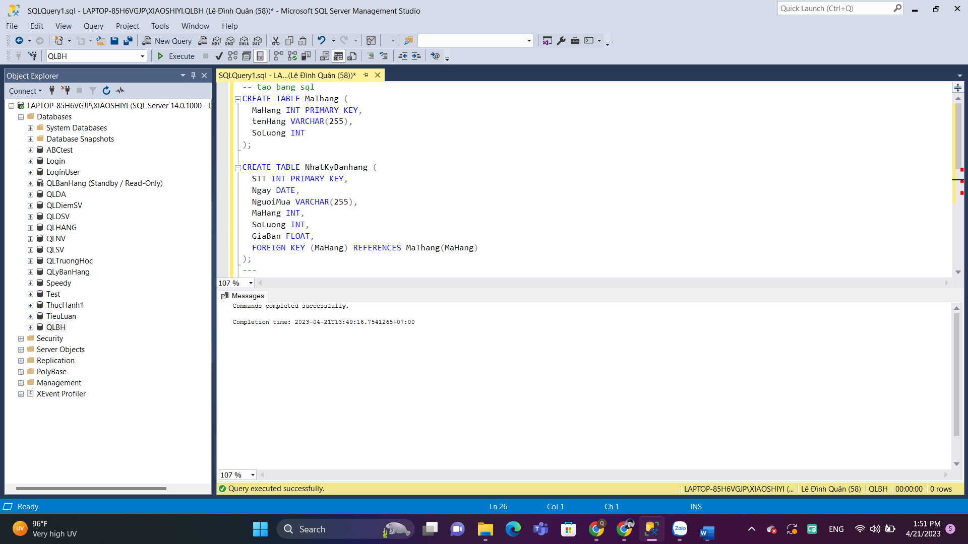

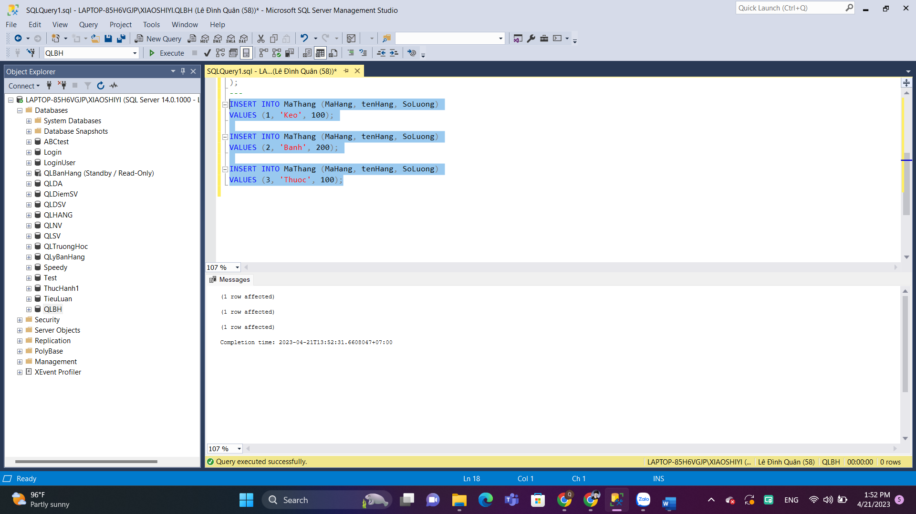

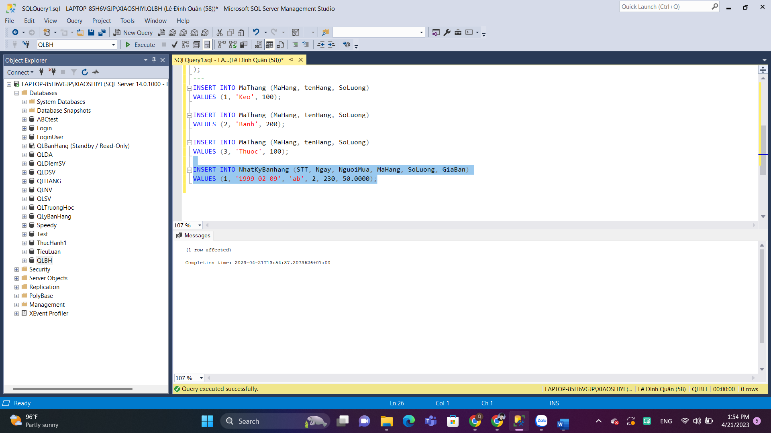

Cau a

Cau b

Câu c

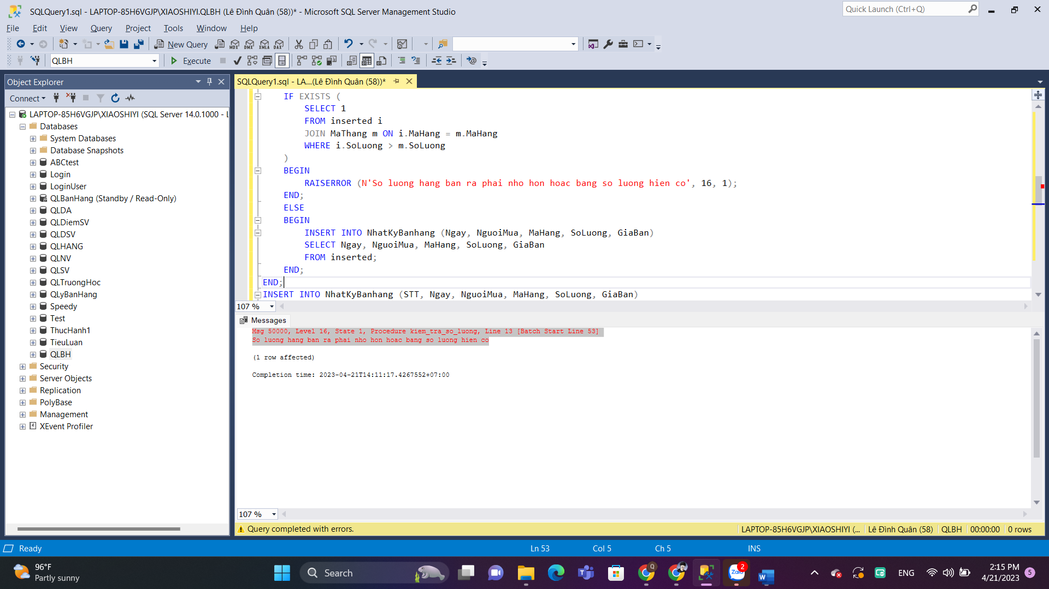

Câu d

Cau e

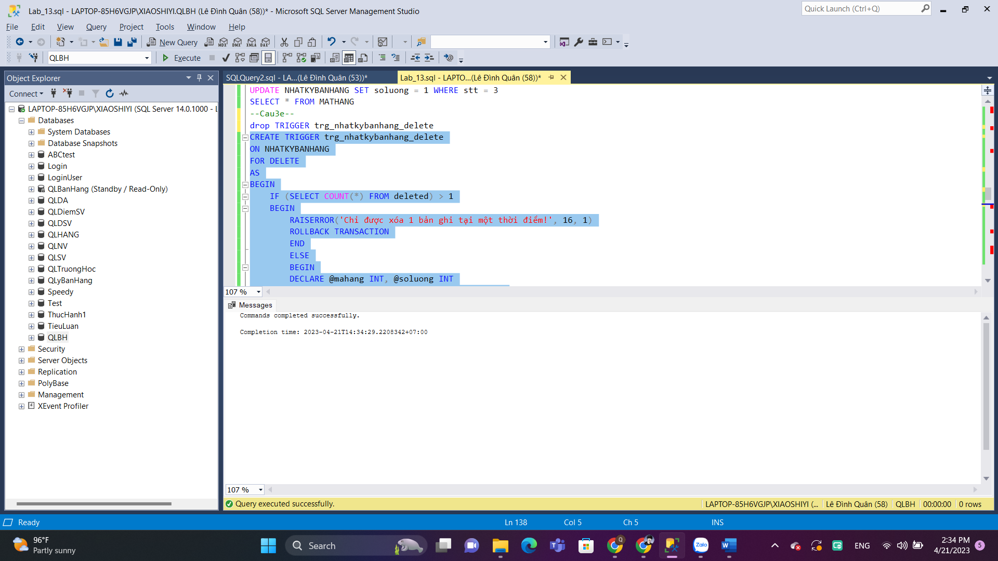

Cau f

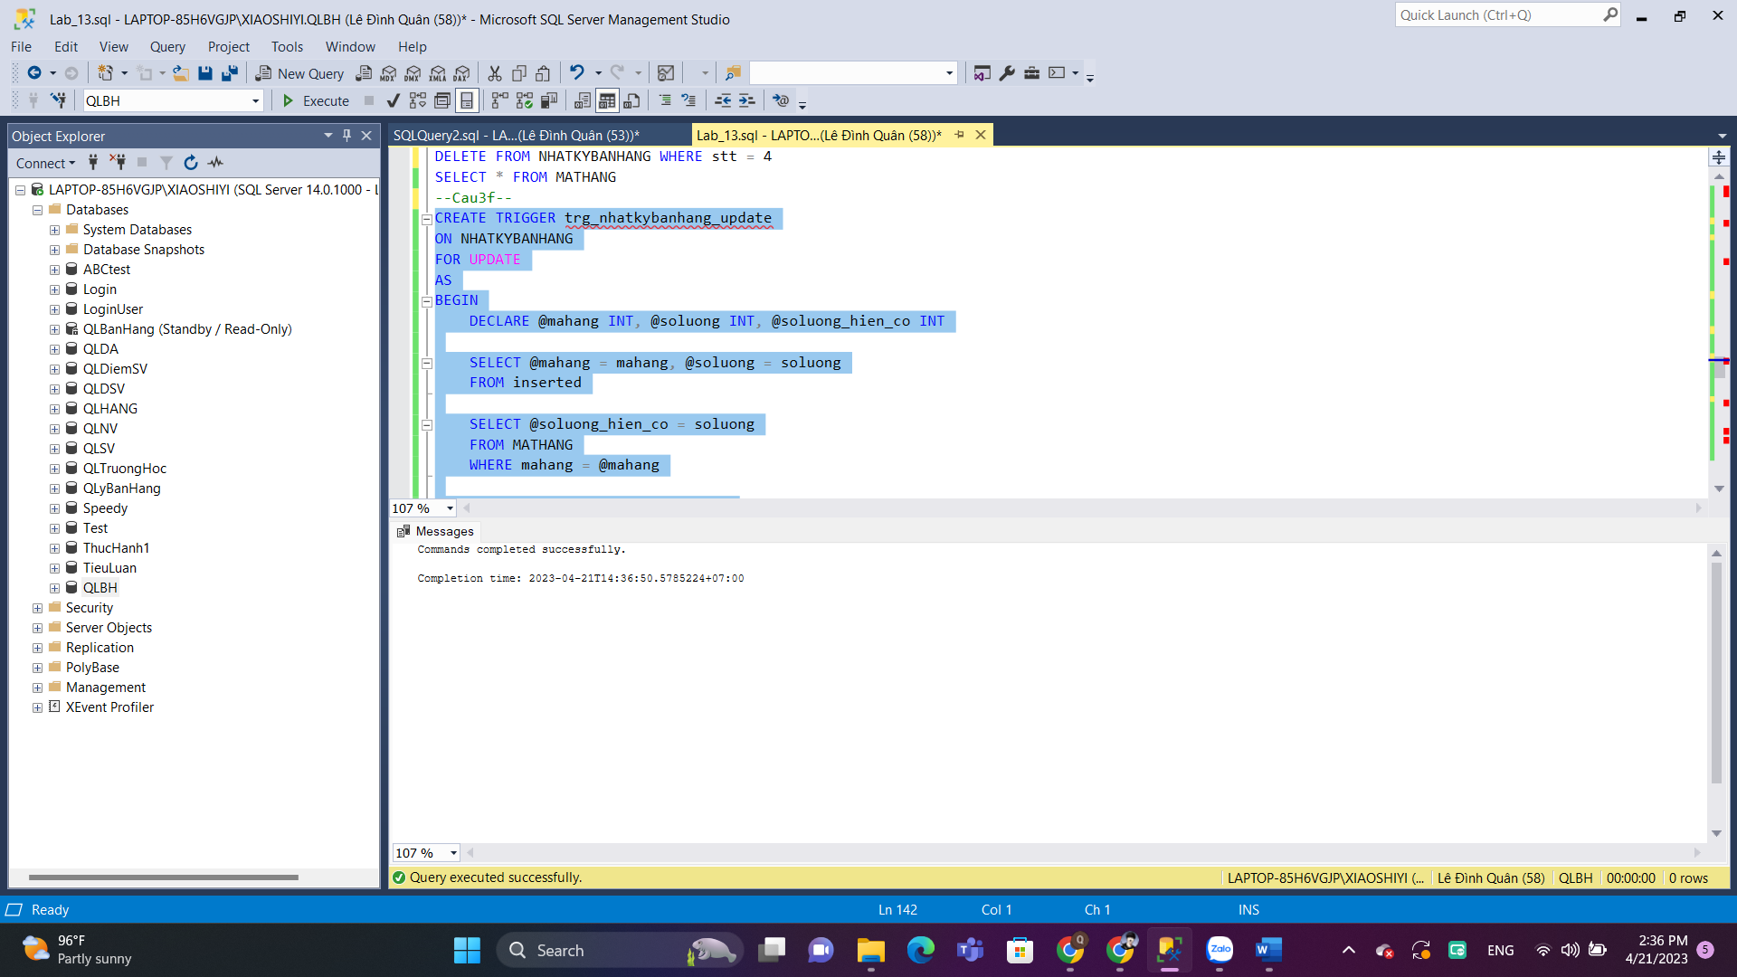

Câu g

Câu h

Câu i



